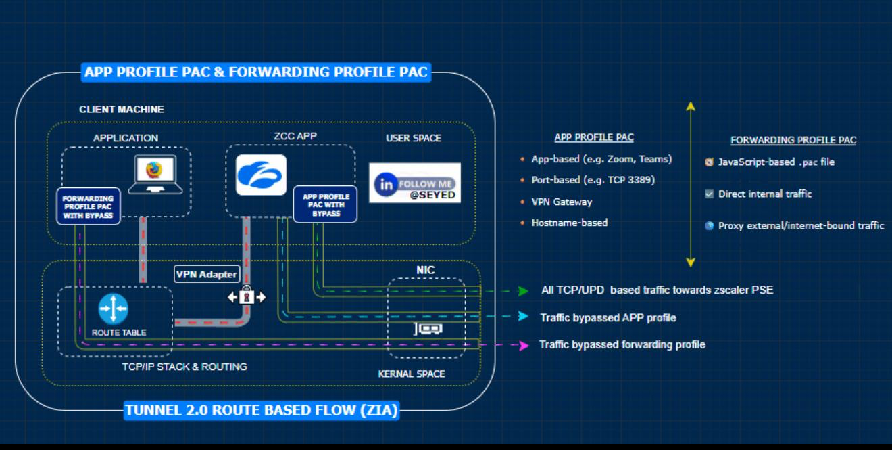
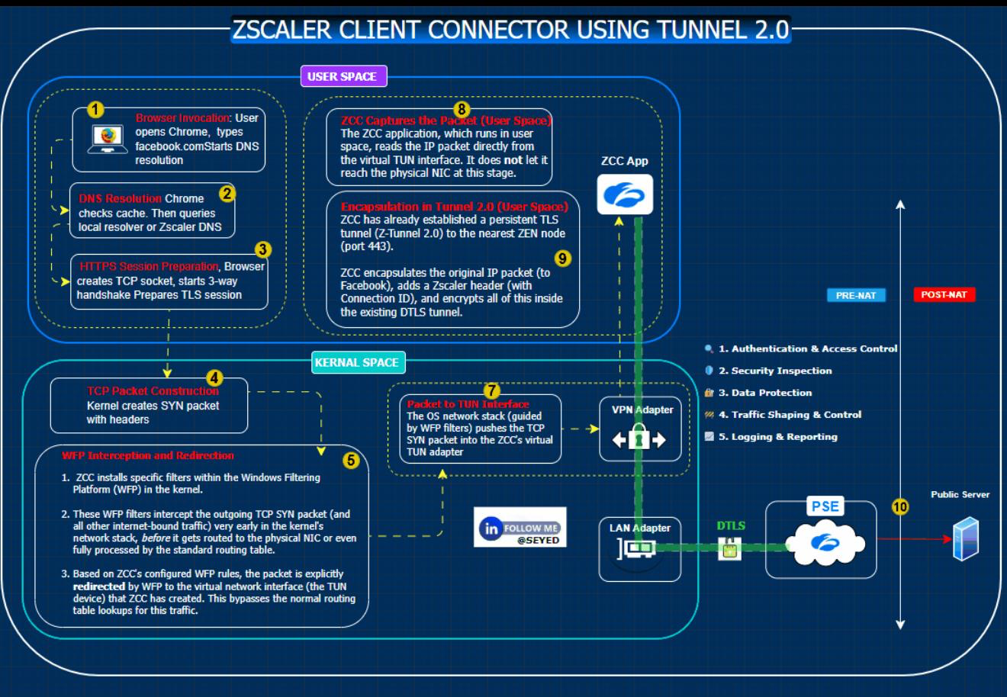

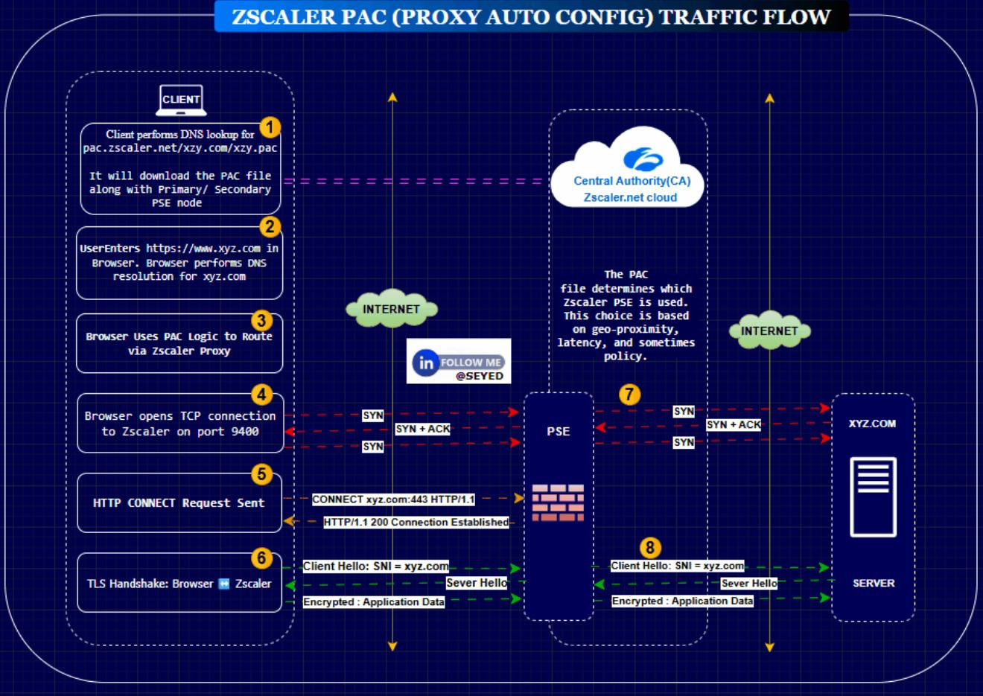
ZPA Solution Standard + ZPA with SIPA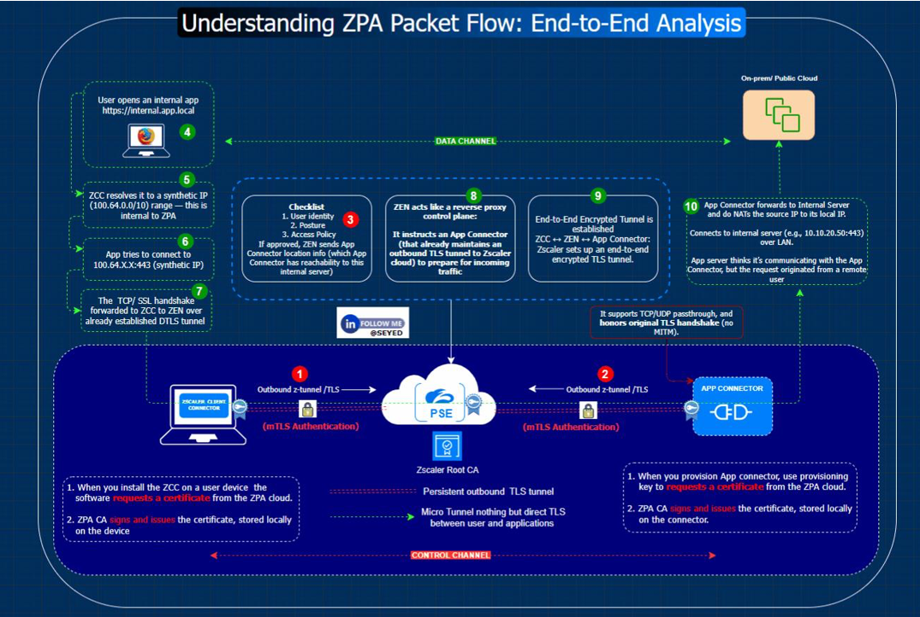
SIPA Solution
𝐙𝐬𝐜𝐚𝐥𝐞𝐫 𝐒𝐈𝐏𝐀 (𝐒𝐎𝐔𝐑𝐂𝐄 𝐈𝐏 𝐀𝐧𝐜𝐡𝐨𝐫𝐢𝐧𝐠) – 𝐊𝐞𝐲 𝐔𝐬𝐞 𝐂𝐚𝐬𝐞s
In a cloud-first world, many organizations face challenges with traffic egressing through shared cloud proxy IPs. Zscaler’s Service IP Anchoring (SIPA) solves this by letting enterprises use their own static, trusted public IPs while still benefiting from Zscaler’s cloud security.
- 𝐍𝐨 𝐋𝐨𝐜𝐚𝐥 𝐏𝐎𝐏 𝐨𝐫 𝐆𝐚𝐭𝐞𝐰𝐚𝐲 𝐢𝐧 𝐚 𝐑𝐞𝐠𝐢𝐨𝐧
In some countries, Zscaler may not have a local data center (POP). Traffic is forced to exit via a nearby country, which may cause higher latency, suboptimal routing, and compliance concerns.
With SIPA, traffic can be anchored to enterprise-owned public IPs. Applications recognize the traffic as local, which reduces geo-blocking and ensures compliance.

- 𝐂𝐥𝐨𝐮𝐝 𝐏𝐫𝐨𝐱𝐲 𝐍𝐀𝐓’𝐞𝐝 𝐈𝐏𝐬 𝐁𝐥𝐨𝐜𝐤𝐞𝐝 𝐛𝐲 𝐎𝐫𝐠𝐚𝐧𝐢𝐳𝐚𝐭𝐢𝐨𝐧𝐬
Some banks, government agencies, or enterprises block Zscaler’s shared proxy IPs. This prevents users behind Zscaler from reaching critical services.
With SIPA, traffic exits using customer-owned static IPs instead of Zscaler NAT IPs. Destinations treat this traffic as trusted and allow access, improving reliability without bypassing security.
- 𝐏𝐚𝐫𝐭𝐧𝐞𝐫/𝐕𝐞𝐧𝐝𝐨𝐫 𝐖𝐡𝐢𝐭𝐞𝐥𝐢𝐬𝐭𝐢𝐧𝐠 𝐎𝐧𝐥𝐲 𝐓𝐫𝐮𝐬𝐭𝐞𝐝 𝐈𝐏𝐬
Many partners or vendors only whitelist a fixed set of static IPs and will not whitelist Zscaler’s dynamic proxy IPs.
With SIPA, customers can anchor traffic through their own public IPs, which partners can safely whitelist. This ensures seamless and trusted communication while keeping Zscaler inspection active.



